COOCH BEHAR NELC SCHOOL FOR THE BLIND SOCIETY
N.E.L.C. BLIND SCHOOL, AIR PORT ROAD, P.O. & Dist. COOCH BEHAR
West Bengal, India, PIN-736101
Phone : 03582 222391,Mobile: 9832043188 email : missionblindschool65@gmail.com
Registered under Society Act, 1961, Registration No. SO112451 OF 2002-2003, Legacy Registration N0. S/IL/12451
====================================================================================================
Annual Report- January to December- 2025
After a wonderful year of 2024, we have started a new year with new hope and new ambition. We have started our new academic year from 2nd January, 2025. Students have scored well in their exams and promoted to new classes.
On 4th January’25 we observed the birth anniversary of Louis Braille in our school auditorium with our students and staffs, followed by some performances by students and a speech about his life, struggle, inventions and dedications to the blind society. We have also explained the importance of his creation of Braille in today’s context.
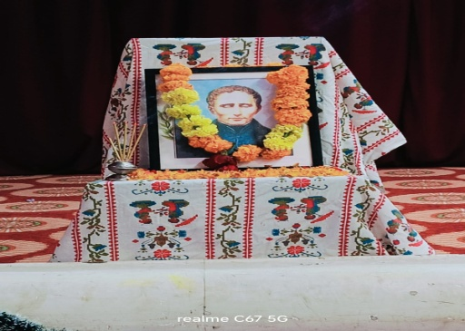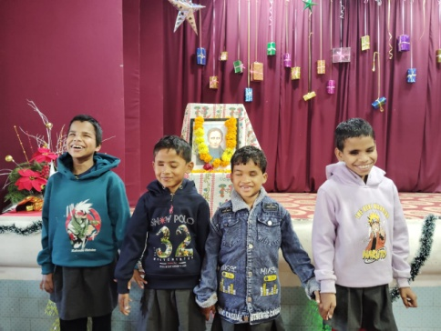
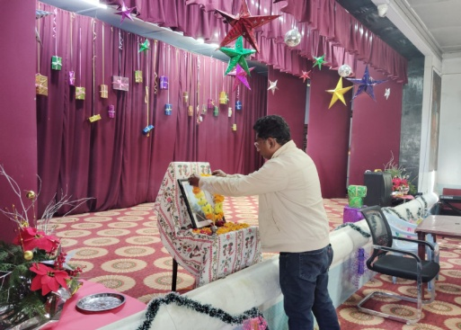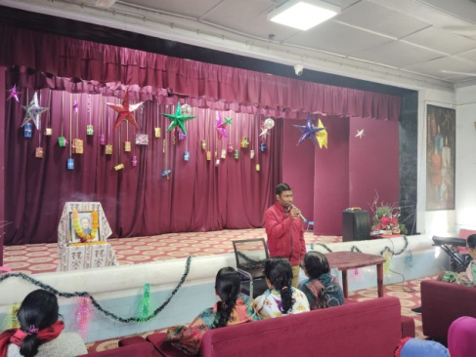
Louis Braille’s Birthday observation
On 8th January’25, we celebrated the 104th birth anniversary of our school Founder Principal Mrs. Brit Hodne, in our Hodne memorial Auditorium. We cherished her memory with songs and a small cake cutting ceremony by our students and along with one of our special guest from Stiftelsen Brödet, Sweden.
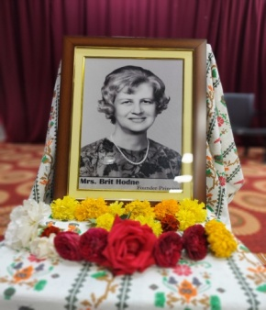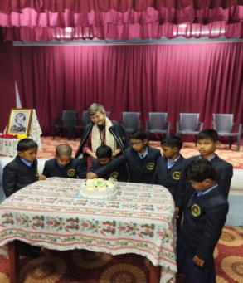
Brit Hodne, Founder Principal, Birthday observation

As the school has made a milestone of completing 60 years serving the visually impaired, this year we had a special celebration on School foundation day from 9th to 10th January. It was a grand celebration with our present and former students, followed by cultural events and musical concerts. It was a nice event followed by many performance and speech. The organization also rendered financial support to some former students.
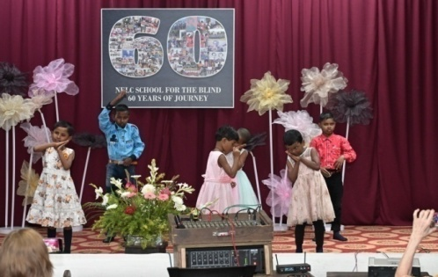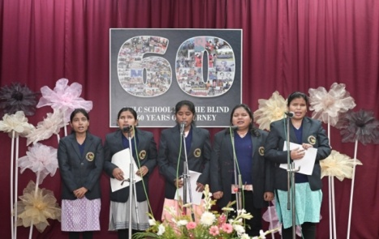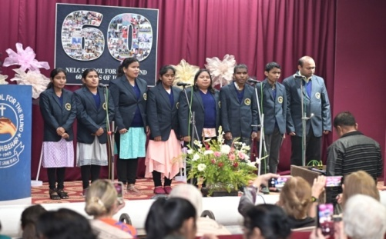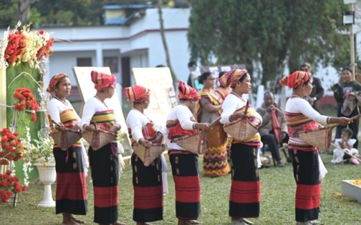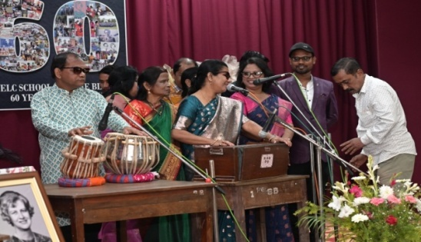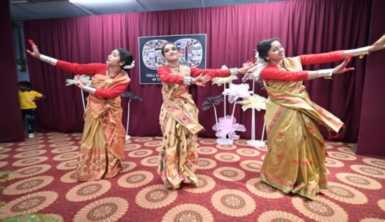

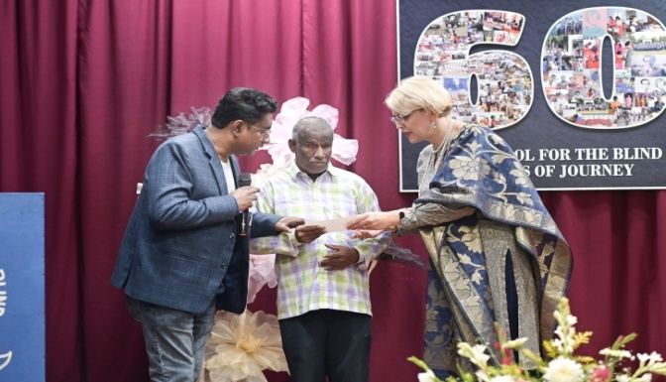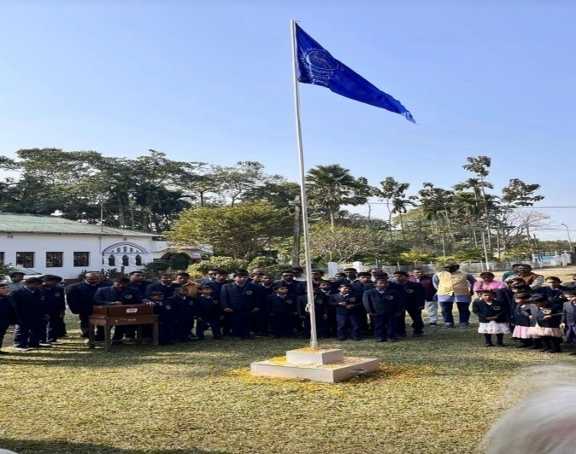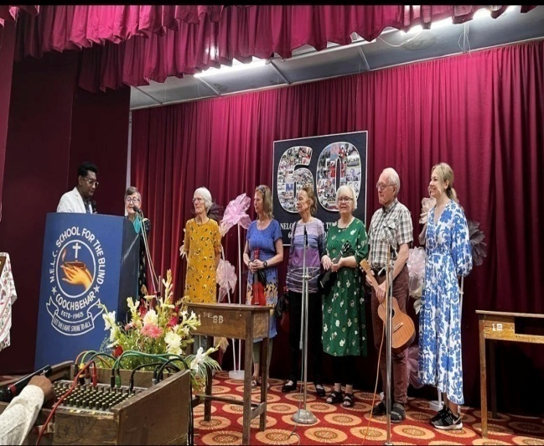
60th Foundation Day celebration with guests from Stiftelsen Brödet, Sweden.

As a part of every academic activity this year also we have done our annual sports in school on 21st January. This is one event students always look for. They started the event with a parade followed by special drill. They not only enjoyed the practicesessions but also participated well in the eventsand did their best

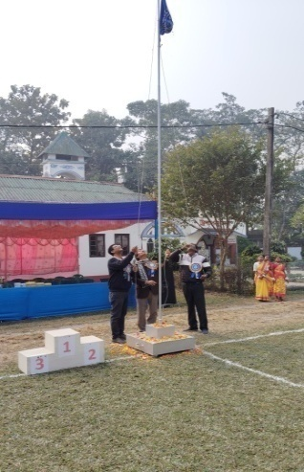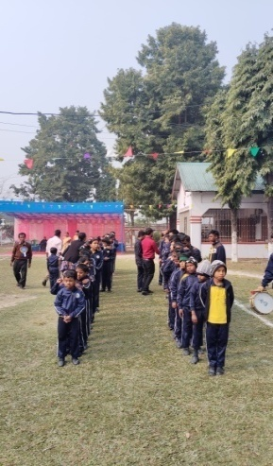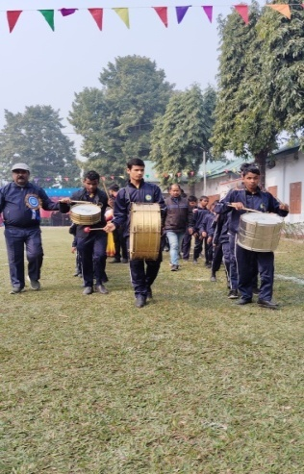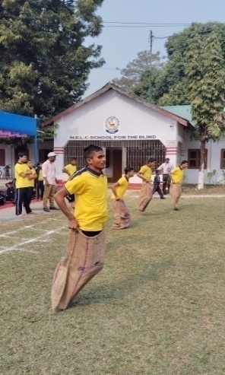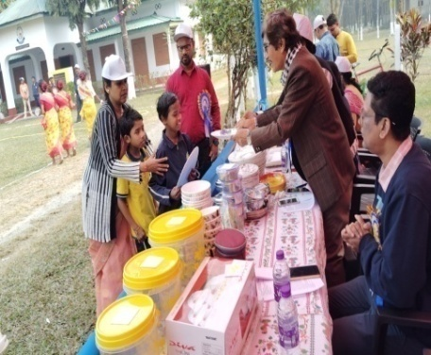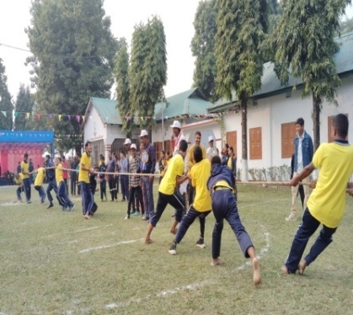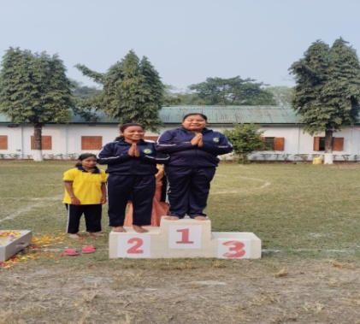
Sports Day
And in 26th January we have observed the Republic day. Students had done a wonderful parade in our school ground and local community, flag hosting has been done and speech given by the principal of the school.
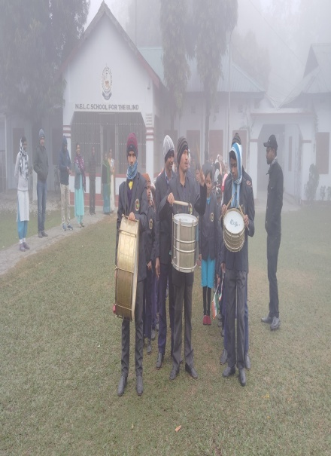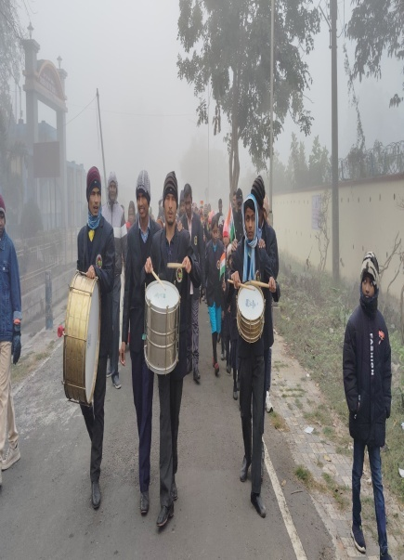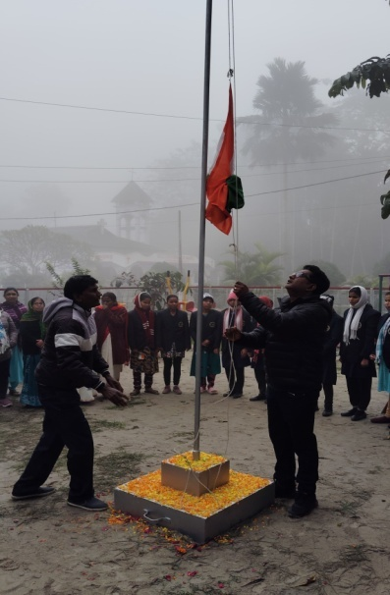
Republic Day Celebration

As refreshment for the students and also to give them a chance to be free from study for once we have organized a school picnic on 1st February.With all our students and staffs. It was a wonderful day as they enjoyed a lot to get a chance to have fun followed by a special lunch and also to participate in many games.
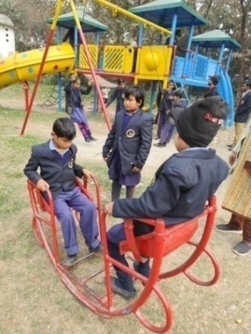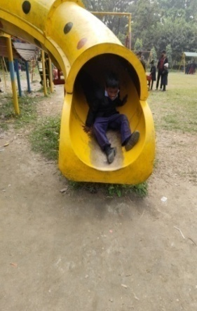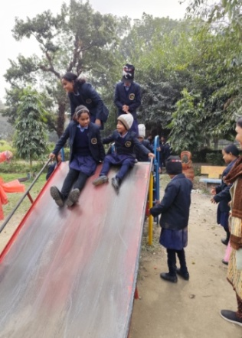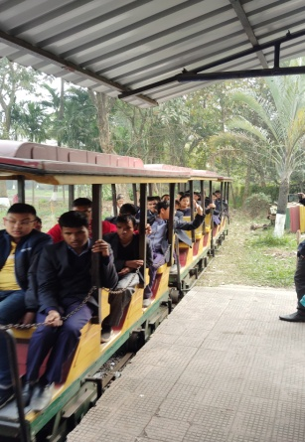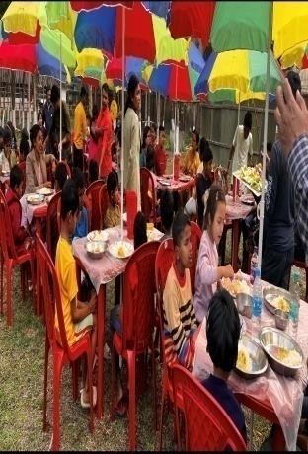
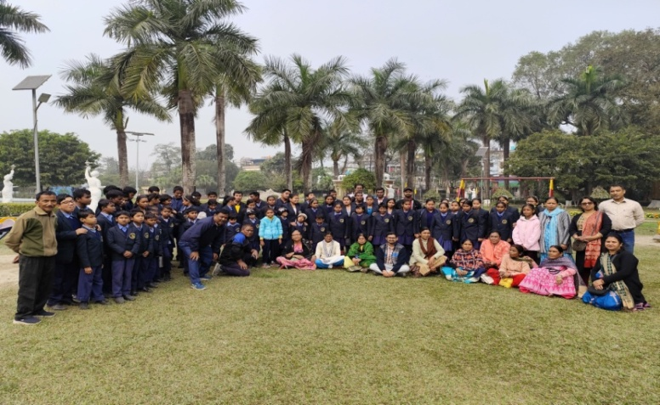
Excursion Day
Like every year this year also our students appeared for their board exams for class X and XII. Results are still pending but we really wish their success in the exams.
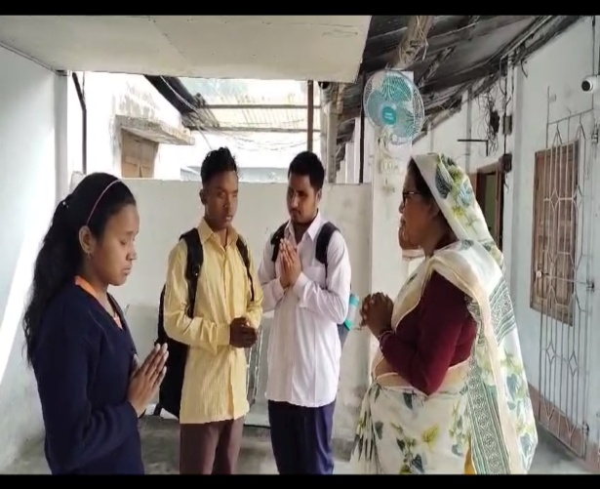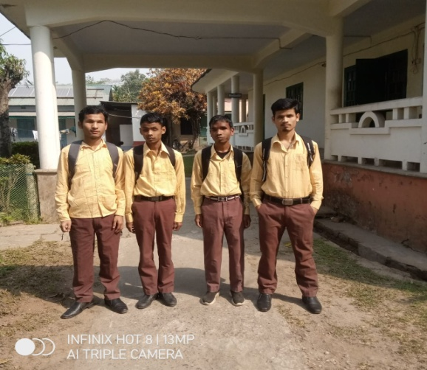
Secondary & Senior Secondary Students, 2025

It’s really a blessing to us that at the beginning of the year itself we are able to welcome our new students in the beginners group. We wish a prosperous life for them ahead.
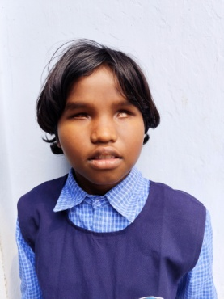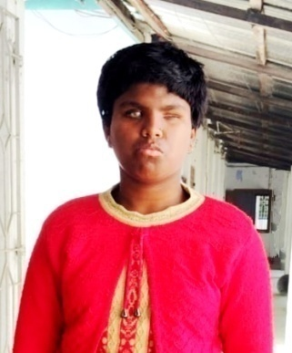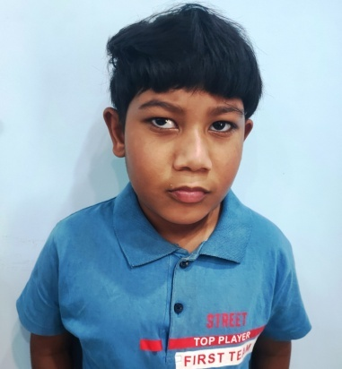
New Admission
From 28th April, 2025 they all appeared for their first trimester term exams and done a great job.
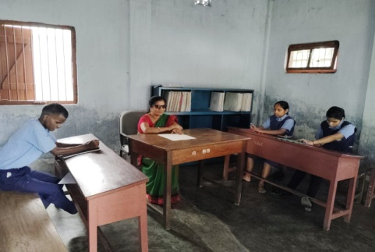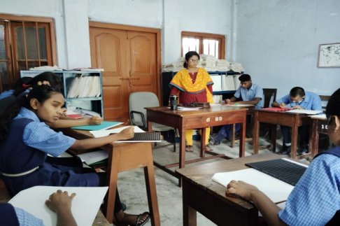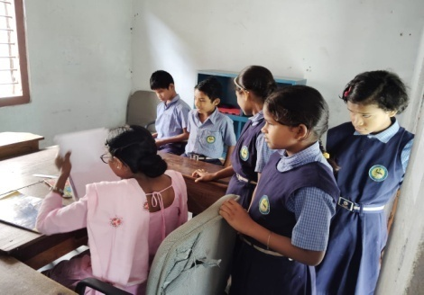
Exam Time

On 30th April, 2025 we have organized a special rally in school to brief specially the pre-adult students about the consequences of early marriage in our society. Students participated in the event along with a briefing session.
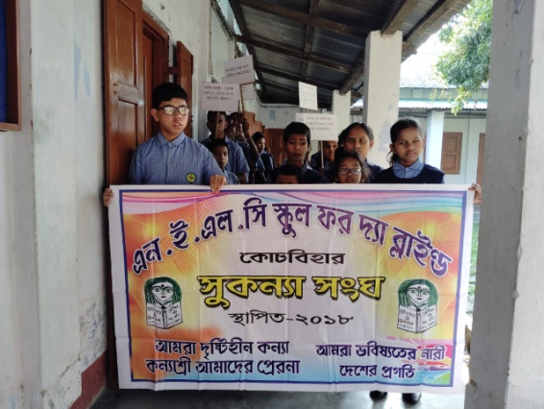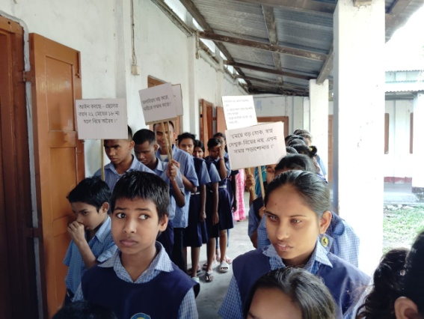
Awareness of Child Marriage

Like every year, before students went off to summer vacation they organised a special cultural programme. They have wonderfully participated in singing , dancing, reciation and drama.
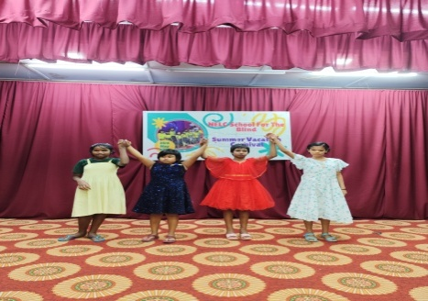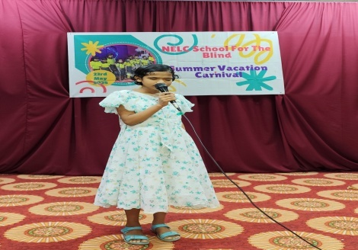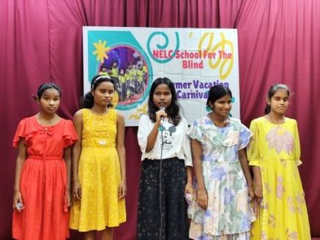
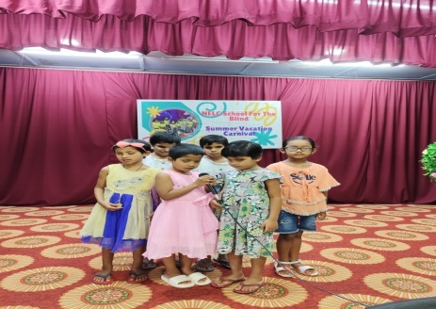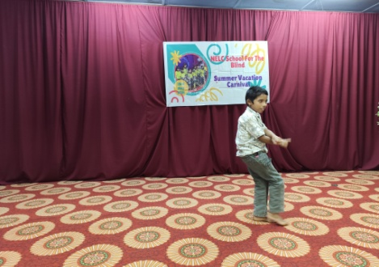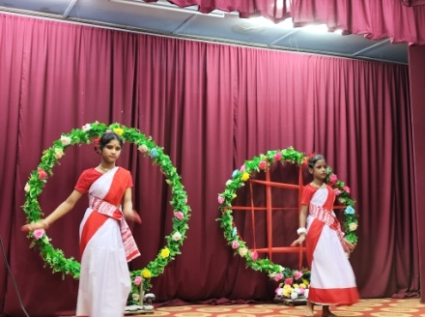
Cultural Programme before summer brea

Before they went back on 24th May, 2025 we have arranged parents teachers meeting, where we have discussed students progress and other issues.

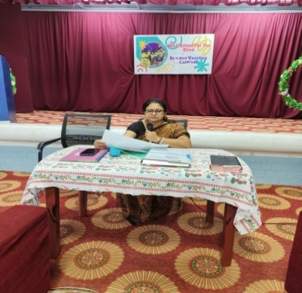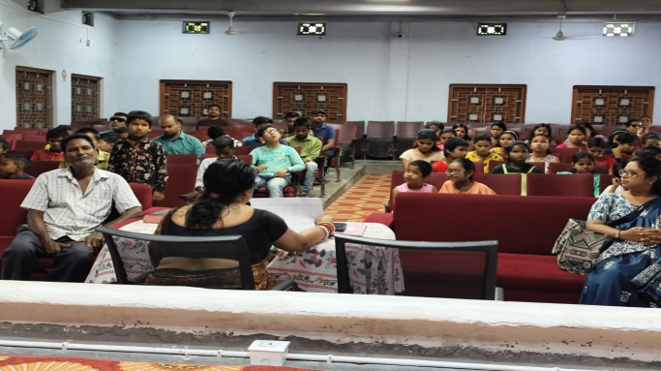
Teachers – Parents Meeting
School was closed for one month due to summer vacation and it reopened on mid of the June and we had good session after break.

On 16th of July we have observed tree plantation as an awareness program where all the students and staffs took part. We have planted many plants in our school campus and play ground.
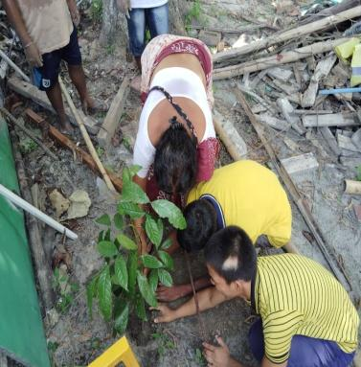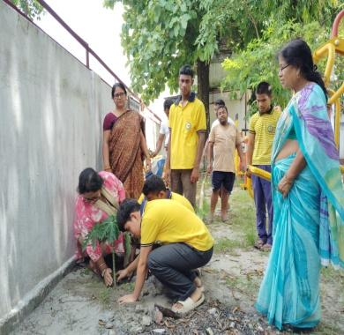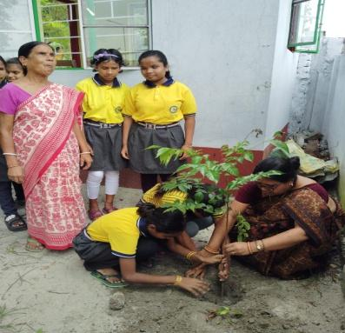
Tree Plantation

On 3rd of August we organized a health camp in our school were doctors came and checked all our students individually and also prescribed necessary medication who ever required.
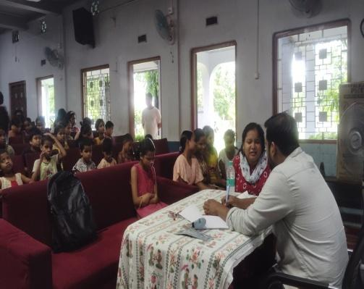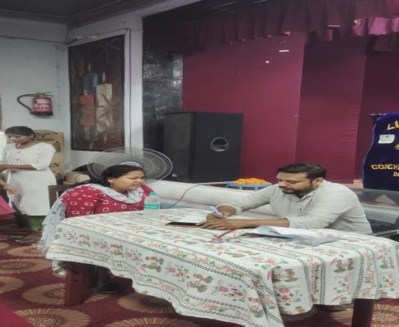
Medical Camp
On 14th of August 2025, we had participated in the Kanyashree day program organized by the District Magistrate Office. Kanyashree project is an initiative taken by the Government of West Bengal to improve the life and the status of the girls by helping economically backward families.
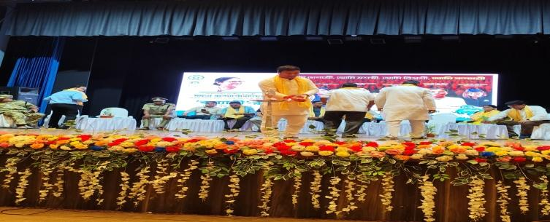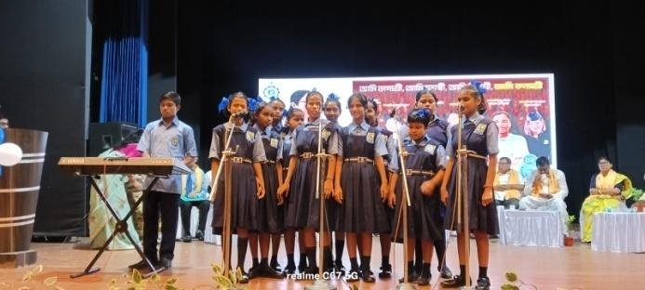
Performing at Kanyashree Program

On the occasion of Independence Day on 15th of August, we had a flag hosting ceremony. We recalled the history of the struggle for independence and also prayed for the well-being of the country.
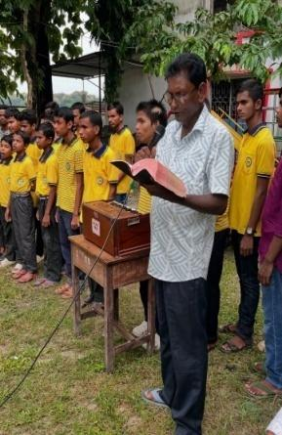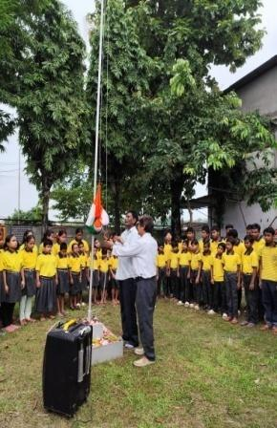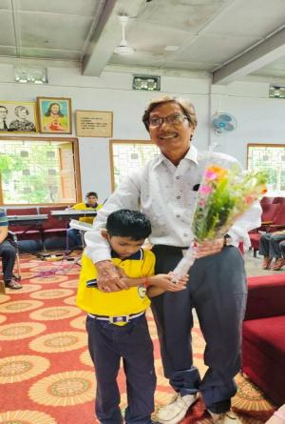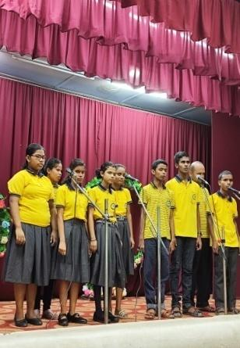
Independence Day

It’s a proud moment to share that one of our student, MahekLakra studying in class VII, went to attend cricket tournament to Bangalore on 15th August, organized by Cricket Association for The Blind. She and one more girl has represented the East Zone of India. The goal of the tournament was to make a team which will represent India in international competitions. Mehek has done really well and we hope for her success in this career.
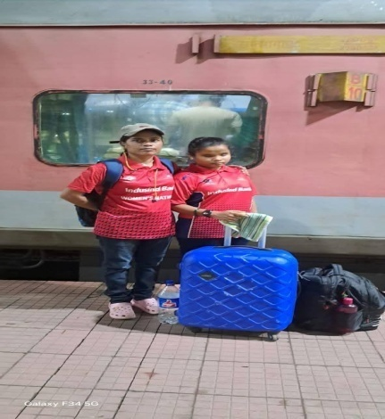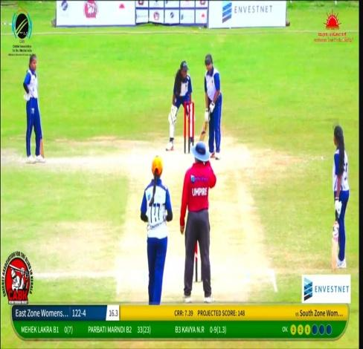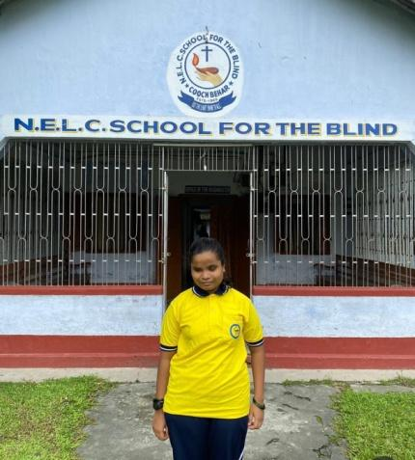
MehekLakra

On 17th of August, 2025 our school participated in a cultural competition organized by Life Insurance Corporation of India (LIC). Our students have participated in group song and recitation and they got third position.
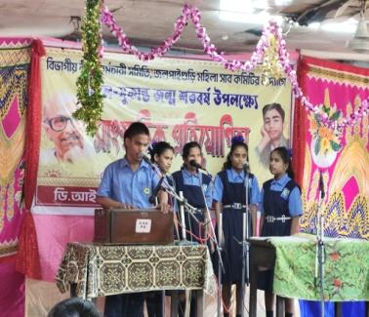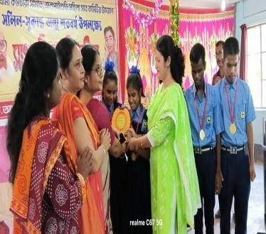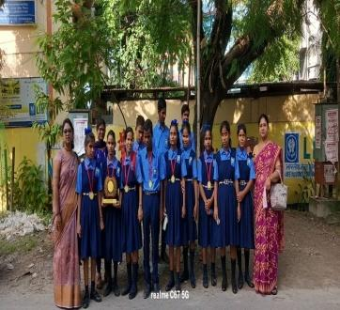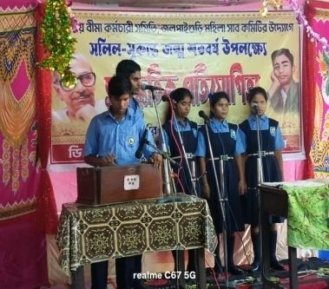
Competition

On 8th of September we participated in a special event on International Literacy Day. The program was organized in our school auditorium, by the Mass Education department, Government of West Bengal. Our students were invited to perform songs. Our student also got prizes in quiz completion. There was also a special program by civil defense where they have given the demonstration of emergency services which was very helpful for the students.
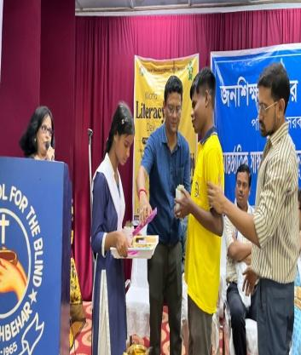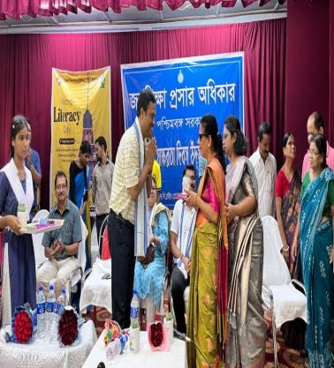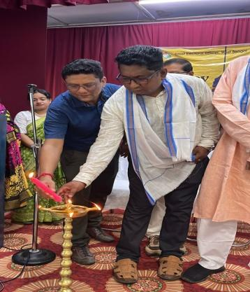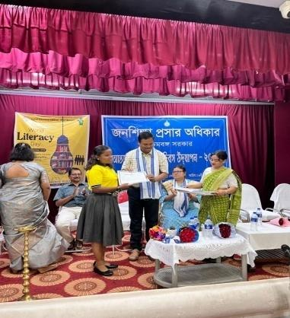
International Literacy Day

As we are approaching towards end of the academic year we conducted our mid-term examination from 16th September onwards. Students have done quite well in their exams.
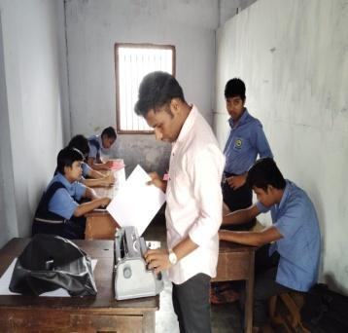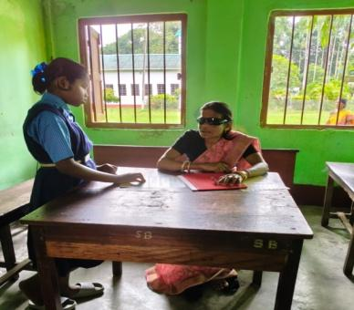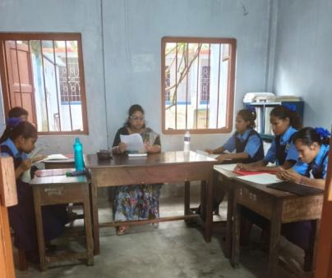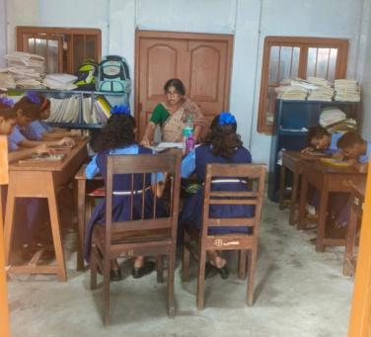
Mid Term Exams
After the successful exam, we have distributed the result on 27th September. Also on that same day parents teachers meeting was conducted, where individual results were shown to the parents along with a brief discussion of school rules and regulations.
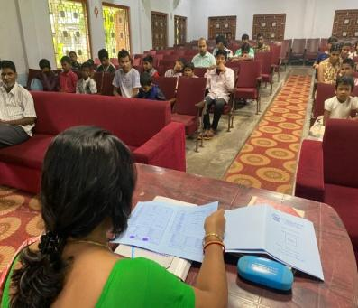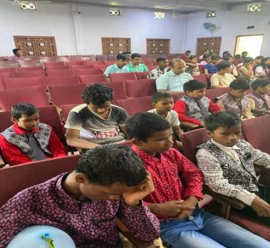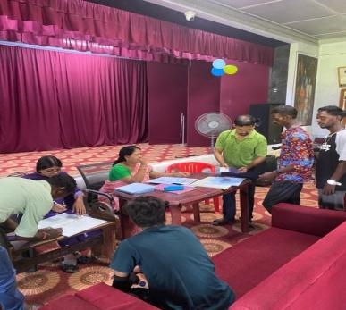
Parents meeting

Children’s Day was celebrated on 14th November with great enthusiasm by all the students and teachers. The students performed confidently and gave their best performances. The programme included various cultural events, followed by class-wise speech and quiz competitions. All the students participated enthusiastically, showed true sportsmanship, and enjoyed the celebrations immensely.
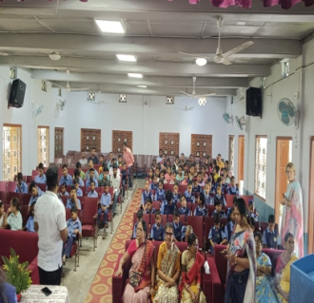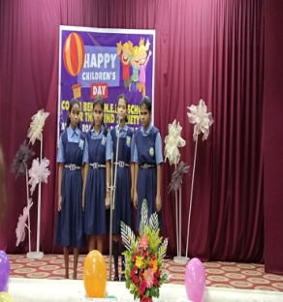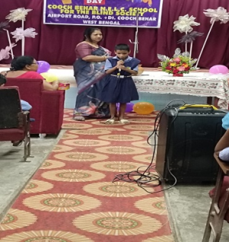
Children’s day program

On 3rd December, a special program was organized on the occasion of World Disabled Day. The students presented meaningful cultural performances, followed by an informative speech to create awareness about the concept of disability. The program emphasized the importance of independence and encouraged students to understand and exercise their rights in society.
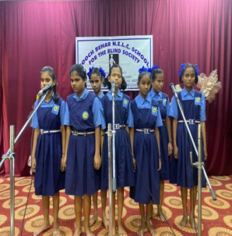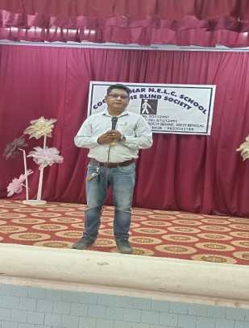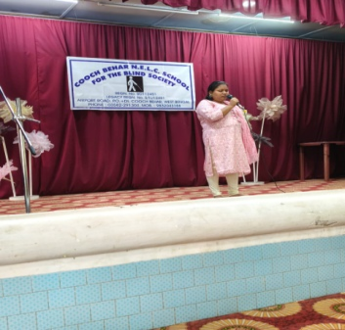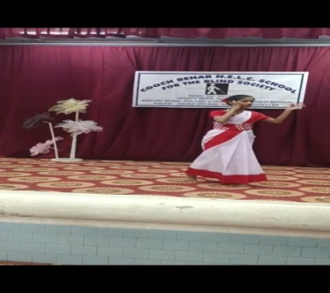
World Disabled Day
As the academic session drew to a close, the school examinations commenced on 4th December onwards. All students appeared for their final assessments and achieved commendable results. Although a few students did not secure full marks, this experience served as a valuable learning opportunity, motivating them to reflect on their performance, strengthen their understanding, and strive for excellence in future examinations.
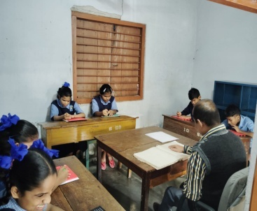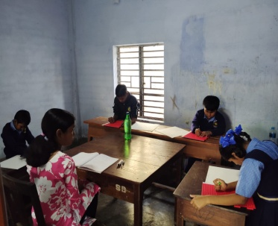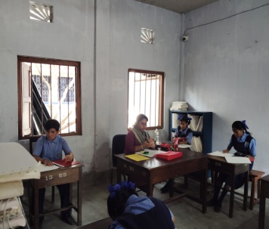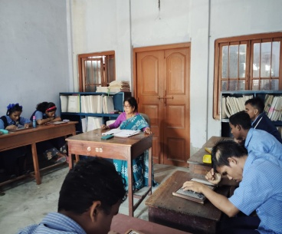
Exam time

With the grace of God and your kind support, we were blessed with the opportunity to bring joy to our children by distributing a small token of love in the form of Christmas gifts on 17th December. The children were delighted to receive the gifts and expressed their happiness and gratitude wholeheartedly.
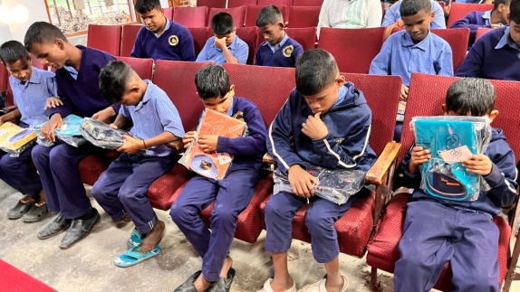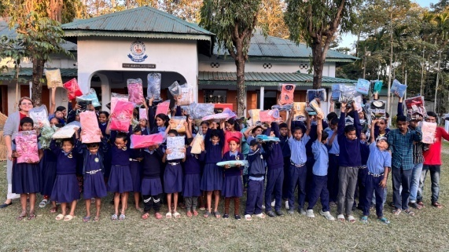
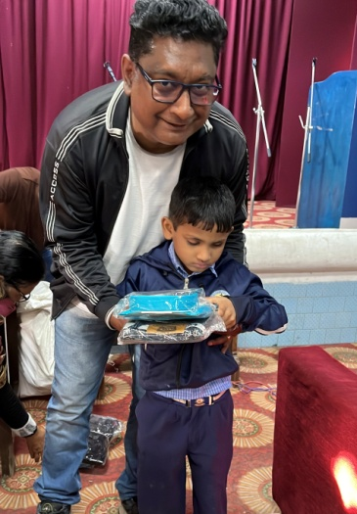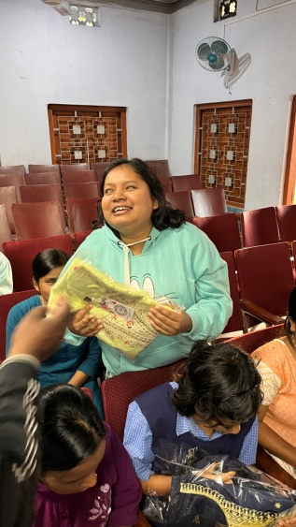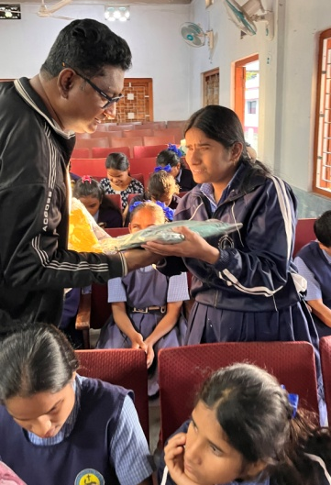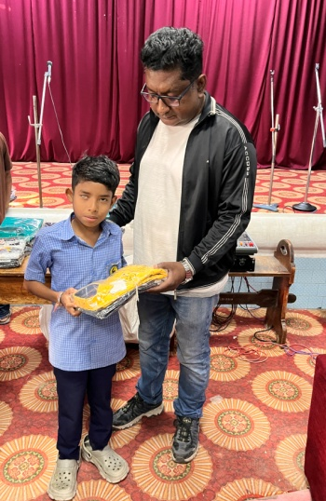
Christmas gifts distribution

This year, on 19th December, our institution hosted a grand Pre-Christmas celebration with the enthusiastic participation of all students and staff members. The occasion was marked by a warm and cheerful tea party, which provided an opportunity for everyone to come together in the true spirit of togetherness and celebration.

The students beautifully showcased their talents through a variety of cultural performances, including singing, dancing, poetry recitation, and drama. Each performance reflected their creativity, confidence, and dedication, captivating the audience and filling the atmosphere with joy and festive cheer. The event not only highlighted the diverse talents of the students but also strengthened the bond between students and staff, making the celebration a memorable and joyful experience for all.
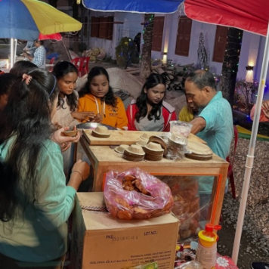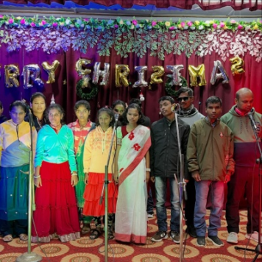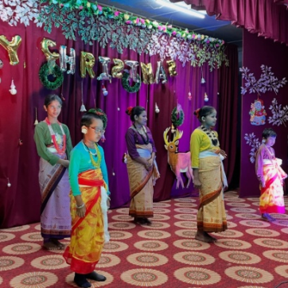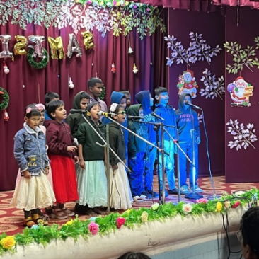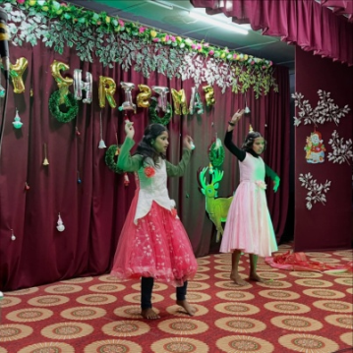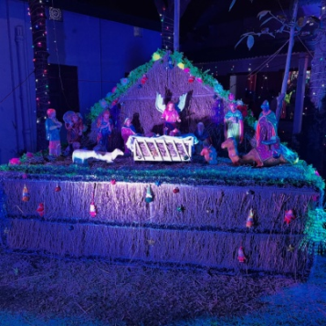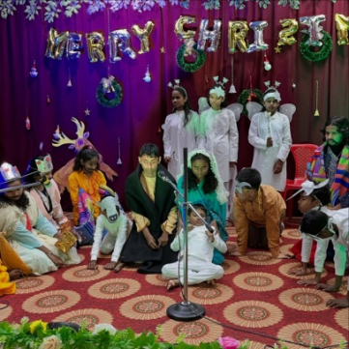
Pre Christmas celebration
The academic session concluded with a Parents–Teachers Meeting, along with the distribution of results, as it marked the final term of the year. Most of the students were promoted to the next class based on their overall performance. However, there remains ample scope for further improvement. We sincerely hope that the coming academic year will be productive and meaningful for all students, enabling them to grow, learn, and progress in every aspect of their lives.
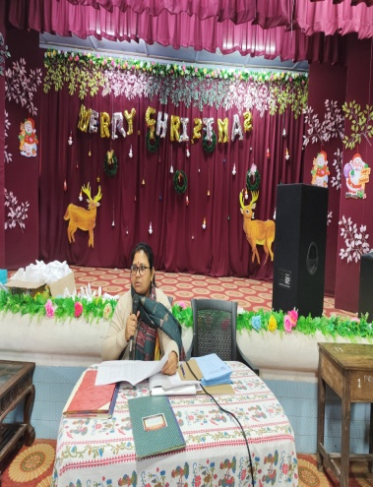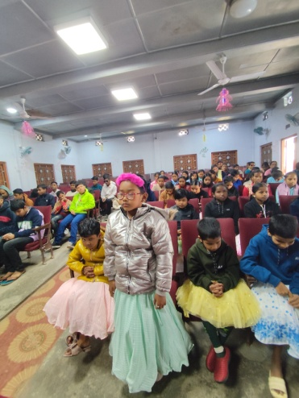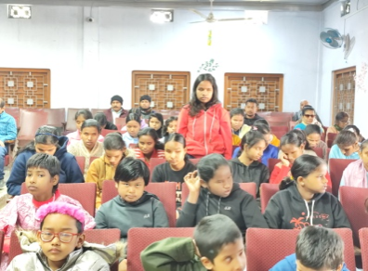
Parent’s teachers meeting
On behalf of all the members of our organization, I would like to express my heartfelt gratitude to each of our valued supporters for your unwavering encouragement and assistance throughout the year, in both challenging and successful times. As we bring this year to a close, we look forward with optimism and confidence, trusting that your continued cooperation and support will accompany us into the year 2026, inspiring new hopes and shared achievements.
Vijay Raj Chhetri
Director/Secretary
Cooch Behar NELC School for the blind society
Cooch Behar, West Bengal, India

